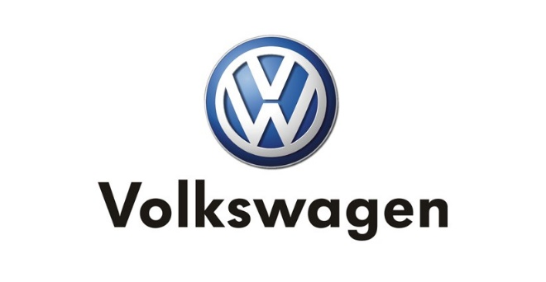Vehicle Sale Form

Vehicle Details

Manufacture: _Volkswagen___________

Vehicle Type: _Passat________________

Pre-Owned: __No___________________

Model MSRP: __20,000______________

Finance Details

Type Of Offer: _Lease______________

Amount Financed: _4,000__________

Paid: ___________________________

Due at Signing: _1,000____________

Lease Price per Month: __50_______

Monthly Payments: _270___________

Lease Term: _36__________________

APR Rate: ___4.0_________________

APR Term: ___36__________________

Sales Details

Sold By: __Jim____________________

Salesman Bonus: __2000____________

Bonus Paid: __No____________________

Bonus Description: __Volkswagen Passat Leased_____________________________

________________________________

Dealership ID: __Chantilly___________

Location Sold: __Ourismman_________

Country: __United States___________

Sold On: __2/21/2018______________

Mileage Responsibility: _28,000______

Dealer Monthly Cont.: _____________

Discount Details:

Loyalty Discount: __No_____________

Coupon Used: __Yes_______________

Coupon Code: _FHFHFH888KFKF______

Signature: _________________________________ Date Submitted: __2/21/2018________